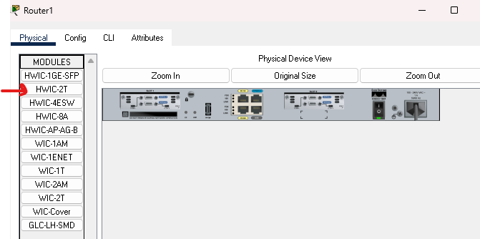
Put in each router
Rip - help to router to pass data
Block list - access control list
Prac 2 -
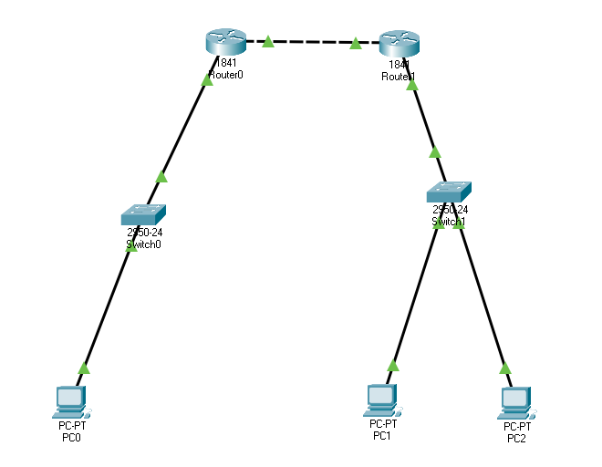
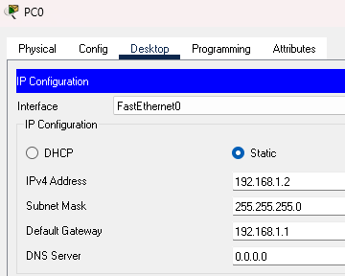
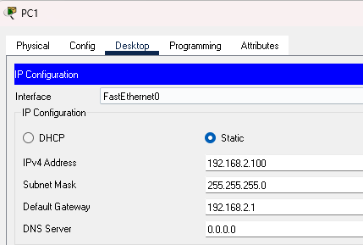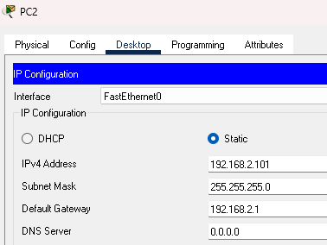
Router 0:
Would you like to enter the initial configuration dialog? [yes/no]: no
Router>en
Router#conf t
Enter configuration commands, one per line. End with CNTL/Z.
Router(config)#int fa0/0
Router(config-if)#ip add 192.168.3.1 255.255.255.0
Router(config-if)#no shut
Router(config-if)#int fa0/1
Router(config-if)#ip add 192.168.1.1 255.255.255.0
Router(config-if)#no shut
Router(config-if)#
%LINK-5-CHANGED: Interface FastEthernet0/1, changed state to up
%LINEPROTO-5-UPDOWN: Line protocol on Interface FastEthernet0/1, changed state to up
ex
Router(config)#exit
Router#
%SYS-5-CONFIG_I: Configured from console by console
Router#
Router#

Router 1:

Router>en
Router#conf t
Enter configuration commands, one per line. End with CNTL/Z.
Router(config)#int fa0/0
Router(config-if)#ip add 192.168.3.2 255.255.255.0
Router(config-if)#no shut

Router(config-if)#
%LINK-5-CHANGED: Interface FastEthernet0/0, changed state to up

%LINEPROTO-5-UPDOWN: Line protocol on Interface FastEthernet0/0, changed state to up

Router(config-if)#int fa0/1
Router(config-if)#ip add 192.168.2.1 255.255.255.0
Router(config-if)#no shut

Router(config-if)#
%LINK-5-CHANGED: Interface FastEthernet0/1, changed state to up

%LINEPROTO-5-UPDOWN: Line protocol on Interface FastEthernet0/1, changed state to up

Router(config-if)#exit
Router(config)#

Router0:
Router(config)#ip route 192.168.2.0 255.255.255.0 192.168.3.2

Router1:
Router(config)#ip route 192.168.1.0 255.255.255.0 192.168.3.1

Router 0:
Router#en
Router#conf t
Enter configuration commands, one per line. End wip route 192.1ip add 192ip route 192.1ip add 192.168.1.1 255.255.255.0ip add 192.168.3.1 255.255.255.0
R0(config-if)#no shut
R0(config-if)#nonexit
R0(cip add 192.168.3.1 255.255.255.0ip add 192.168.1.1 255.255.255.0
R0(config-if)#no shut
R0(config-if)#exit
R0(config)#ip route 192.168.1.0 255.255.255.0 192.168.3.2
R0(config)#exit
R0#

Corrected route:

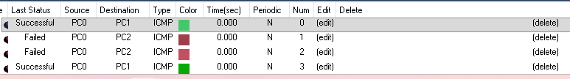

For each pc
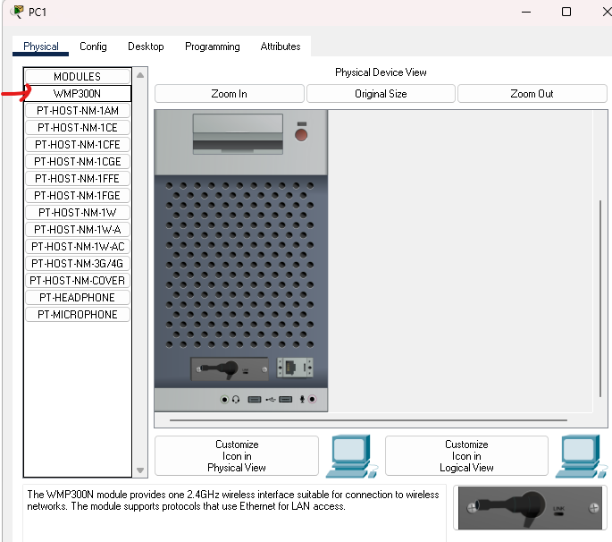
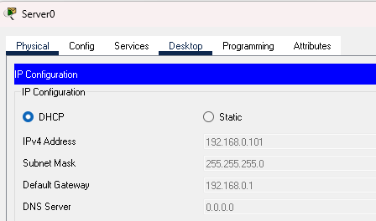
Way 1: Ping used icmp protocol
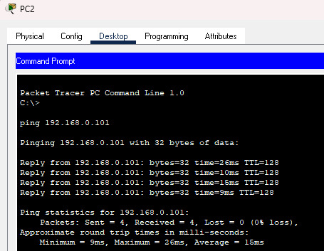

2 way: ip protocol
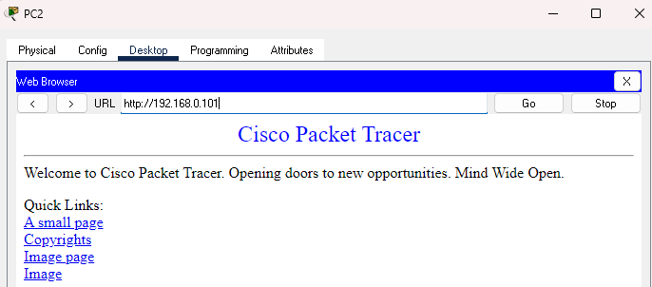

Ad hoc – no base station – temporary basis – eg grp calls

Prac 3
For each pc

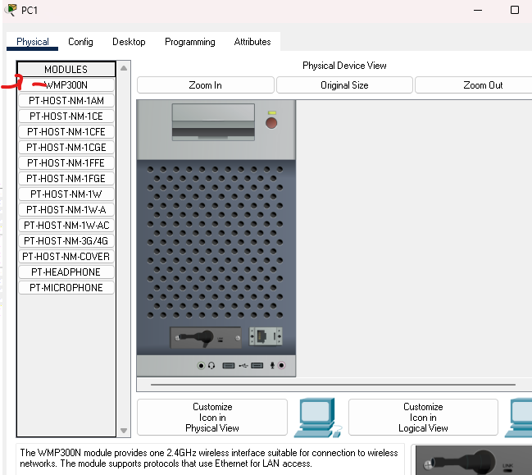
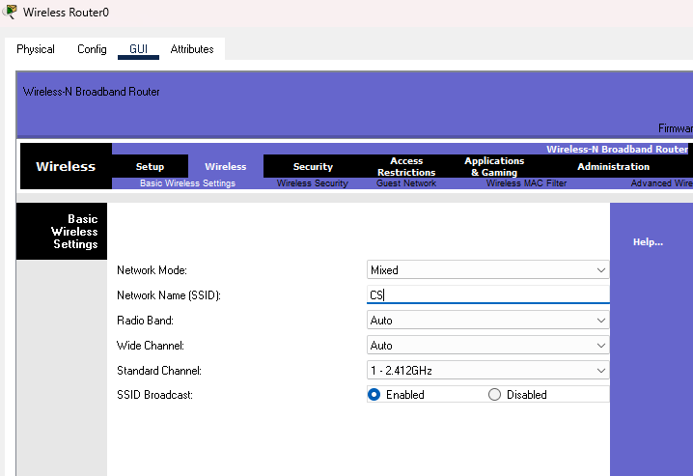
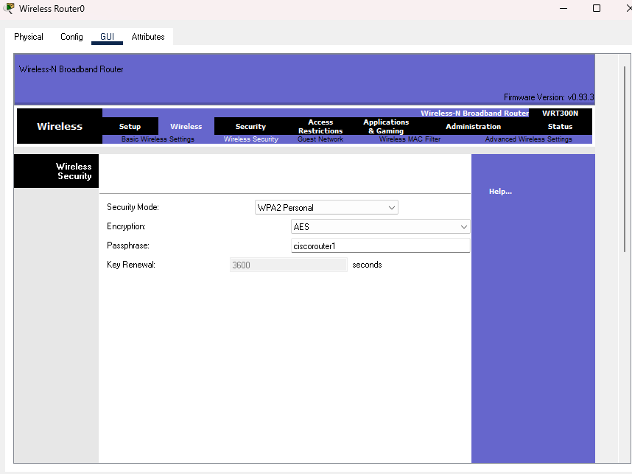
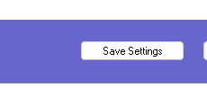
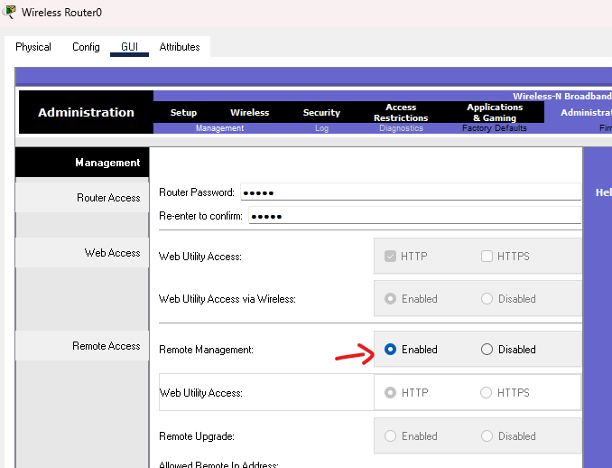
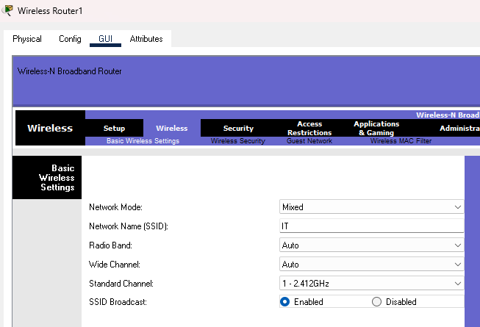
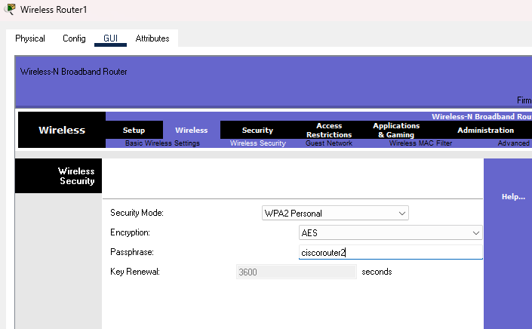
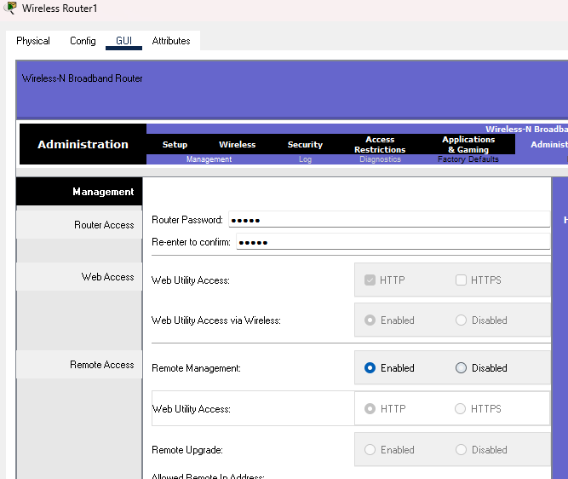

Put password as ciscorouter1 or 2
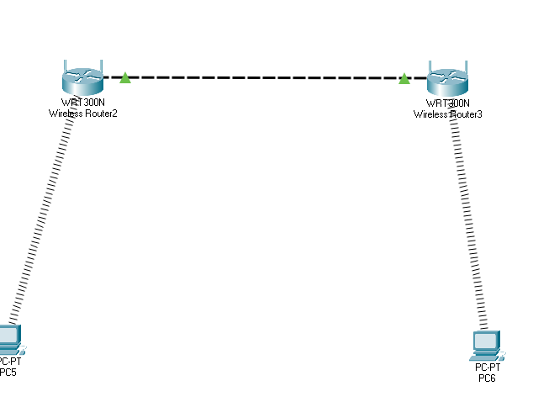
Take 4 pcs

prac4
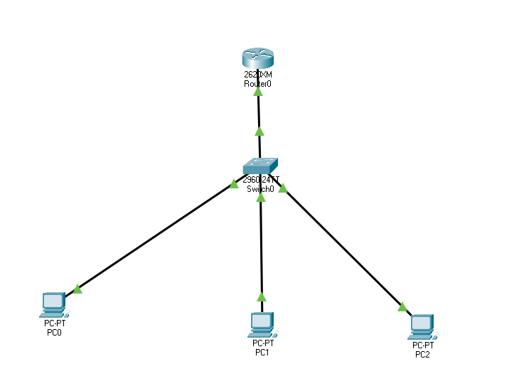
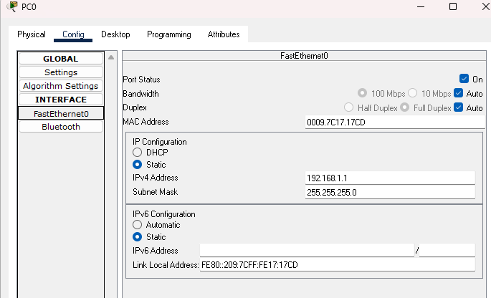
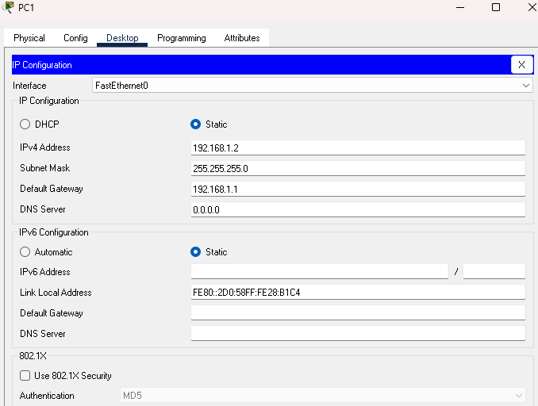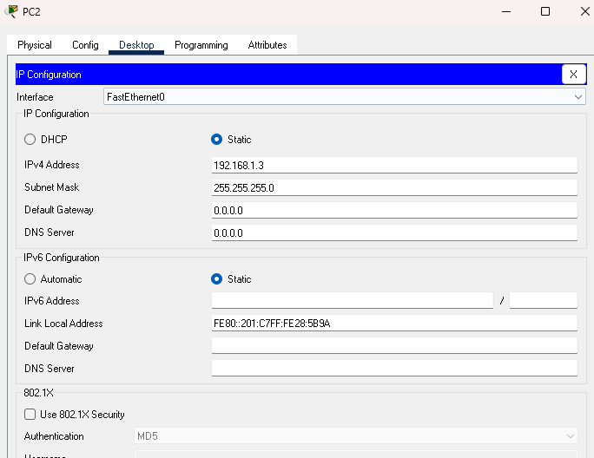
Router:
Router>en
Router#conf t
Enter configuration commands, one per line. End with CNTL/Z.
Router(config)#int fa0/0
Router(config-if)#ip address 192.168.1.1 255.255.255.0
Router(config-if)#no shutdown
Router(config-if)#
%LINK-5-CHANGED: Interface FastEthernet0/0, changed state to up
%LINEPROTO-5-UPDOWN: Line protocol on Interface FastEthernet0/0, changed state to up
Router(config-if)#exit
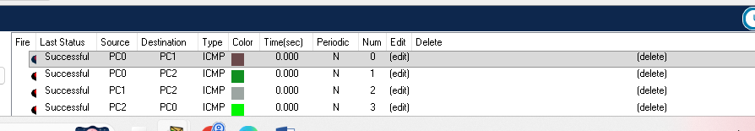

Prac5
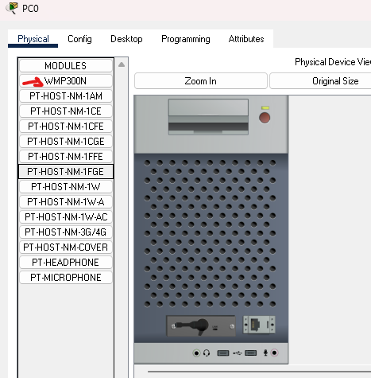
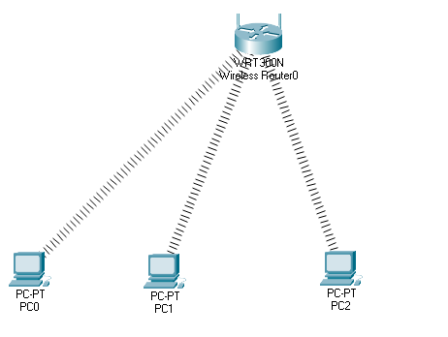

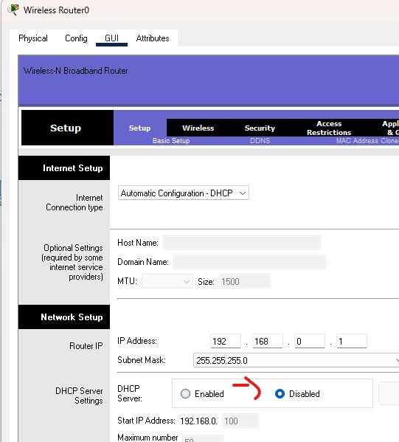
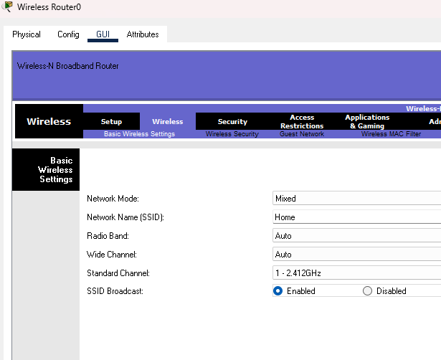
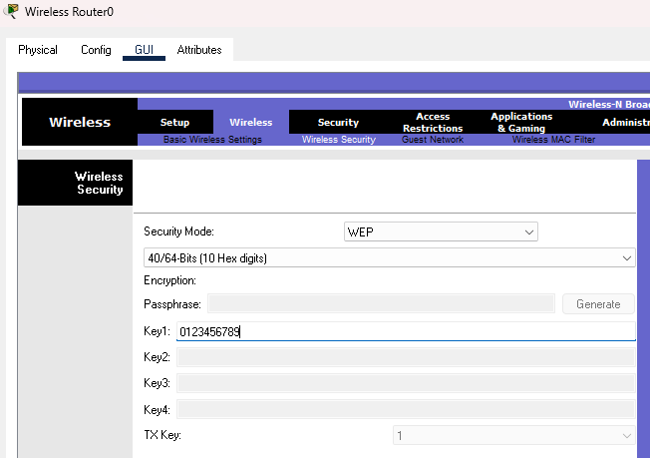
0123456789
For each pc
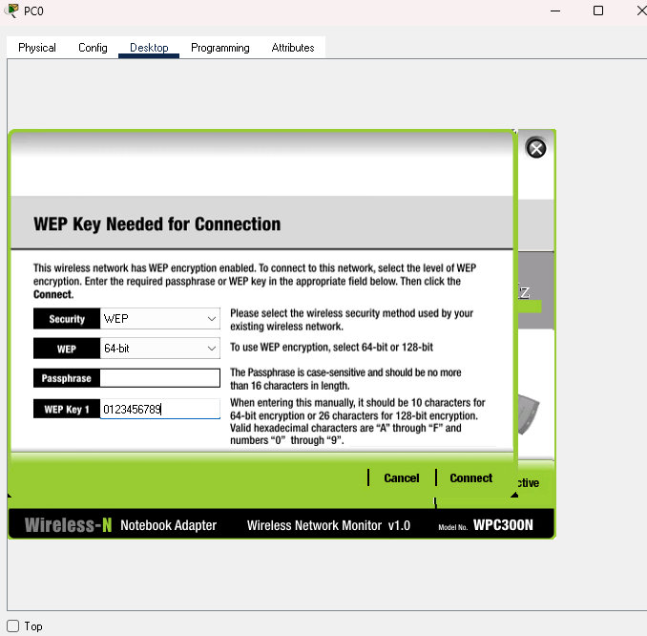
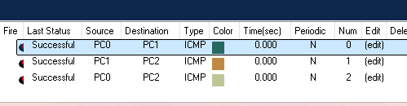

Prac 6
For all pcs

For both routers
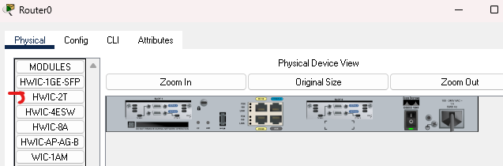
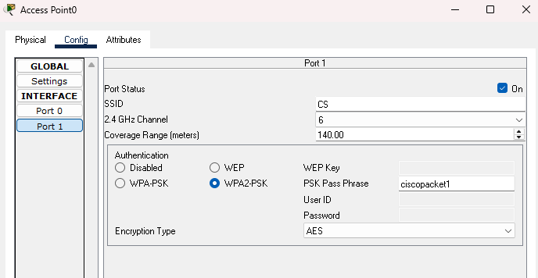
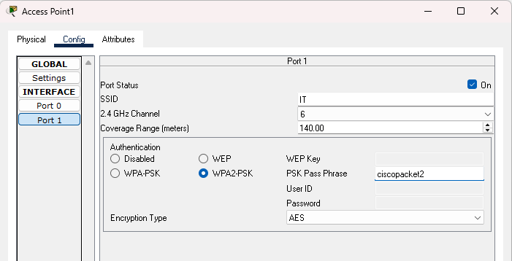
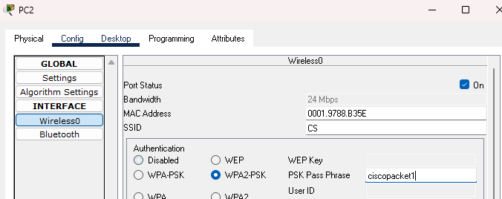
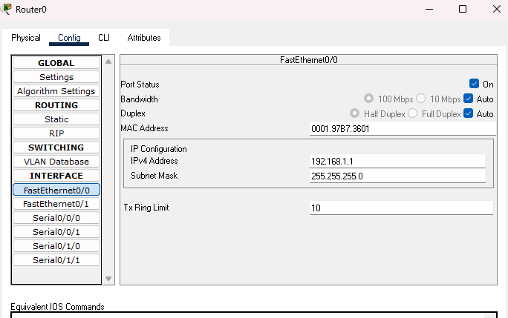
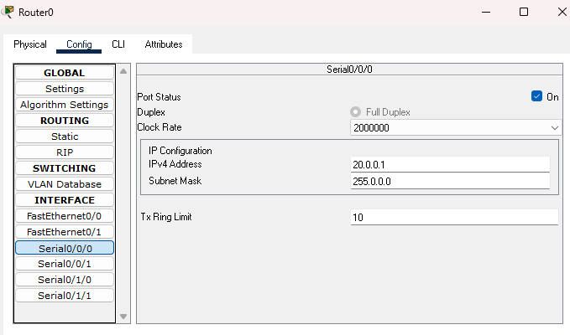
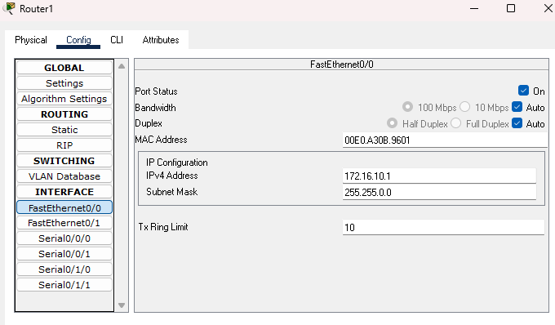
Serial
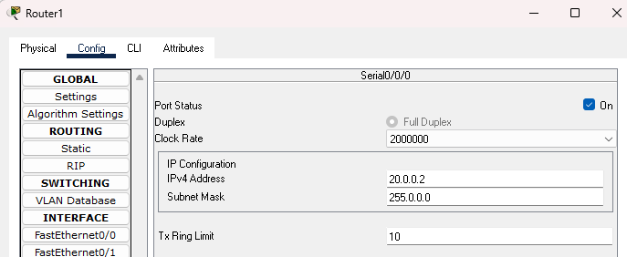
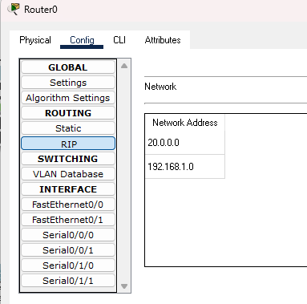

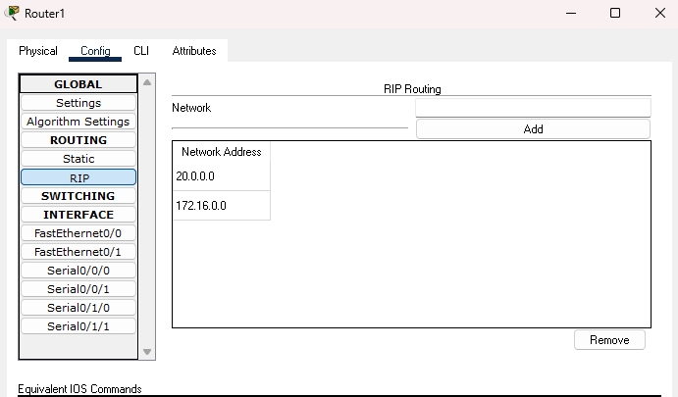
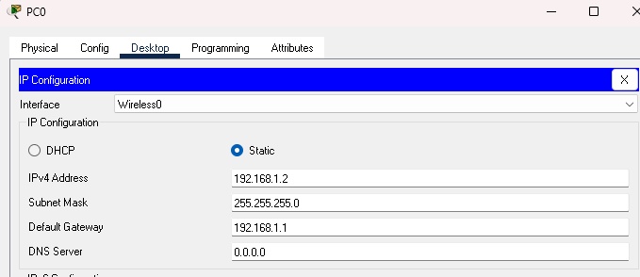
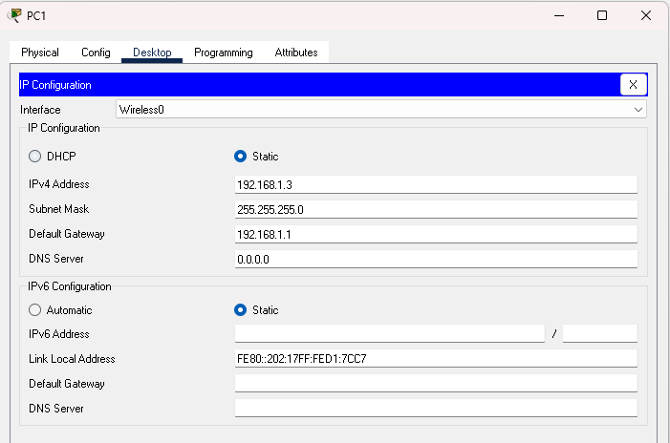
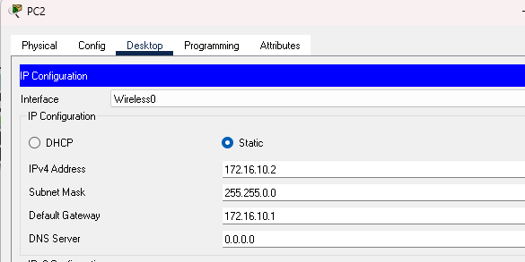
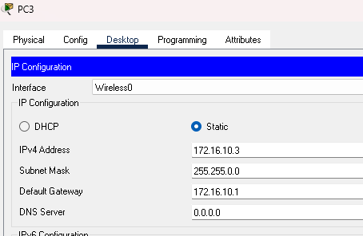
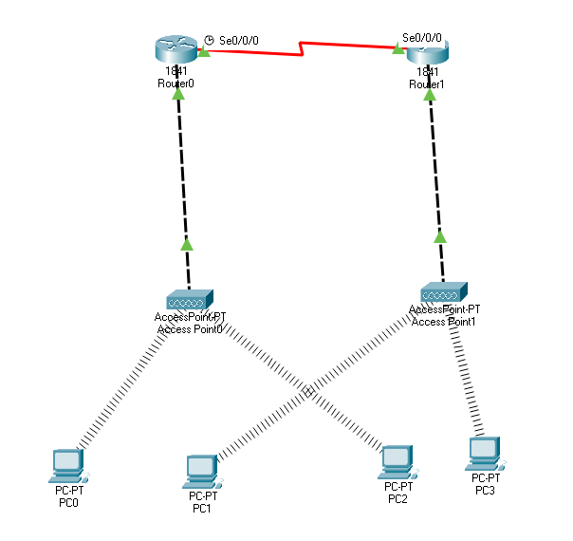
All pcs to share packets
In Wireless Sensor Networks (WSNs), the acronym BLAST usually refers to:
Base-station Location Anonymity and Security Technique [1]
This technique is used to protect the privacy of the base station (sink node) from attackers attempting packet tracing or traffic analysis.
https://ieeexplore.ieee.org/document/6364762/

